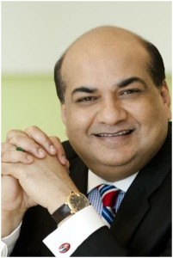

SANDIP DAS (Batch of 1984-86)
PRESIDENT

Group CEO Maxis Communications
Contribution to Indian Telecom

Sandip Das is one of Asia’s most respected telecommunications professional and an
acclaimed Chief Executive.

He was formerly the MD & CEO of Reliance Jio Group, Group of CEO Maxis Communication Berhad, Malaysia and CEO of Hutichson Essar Telecom (now Vodafone), India. He was one of founding members of private telephony in India and was part of group of individuals that founded Hutichson Max Telecom in 1994. He also led one of the world’s largest telecom IPO’s, raising $ 3.5 billion for Maxis in 2009.

